C++ ASSIGNMENT 1.3

\*

\*\*

\*\*\*

\*\*\*\*

\*\*\*\*\*

#include <iostream>

using namespace std;

int main() {

int rows;

// Input the number of rows

cout << "Enter the number of rows: ";

cin >> rows;

// Outer loop for rows

for (int i = 1; i <= rows; ++i) {

// Inner loop for columns

for (int j = 1; j <= i; ++j) {

cout << "\*";

}

cout << endl; // Move to the next line after each row

}

return 0;

}

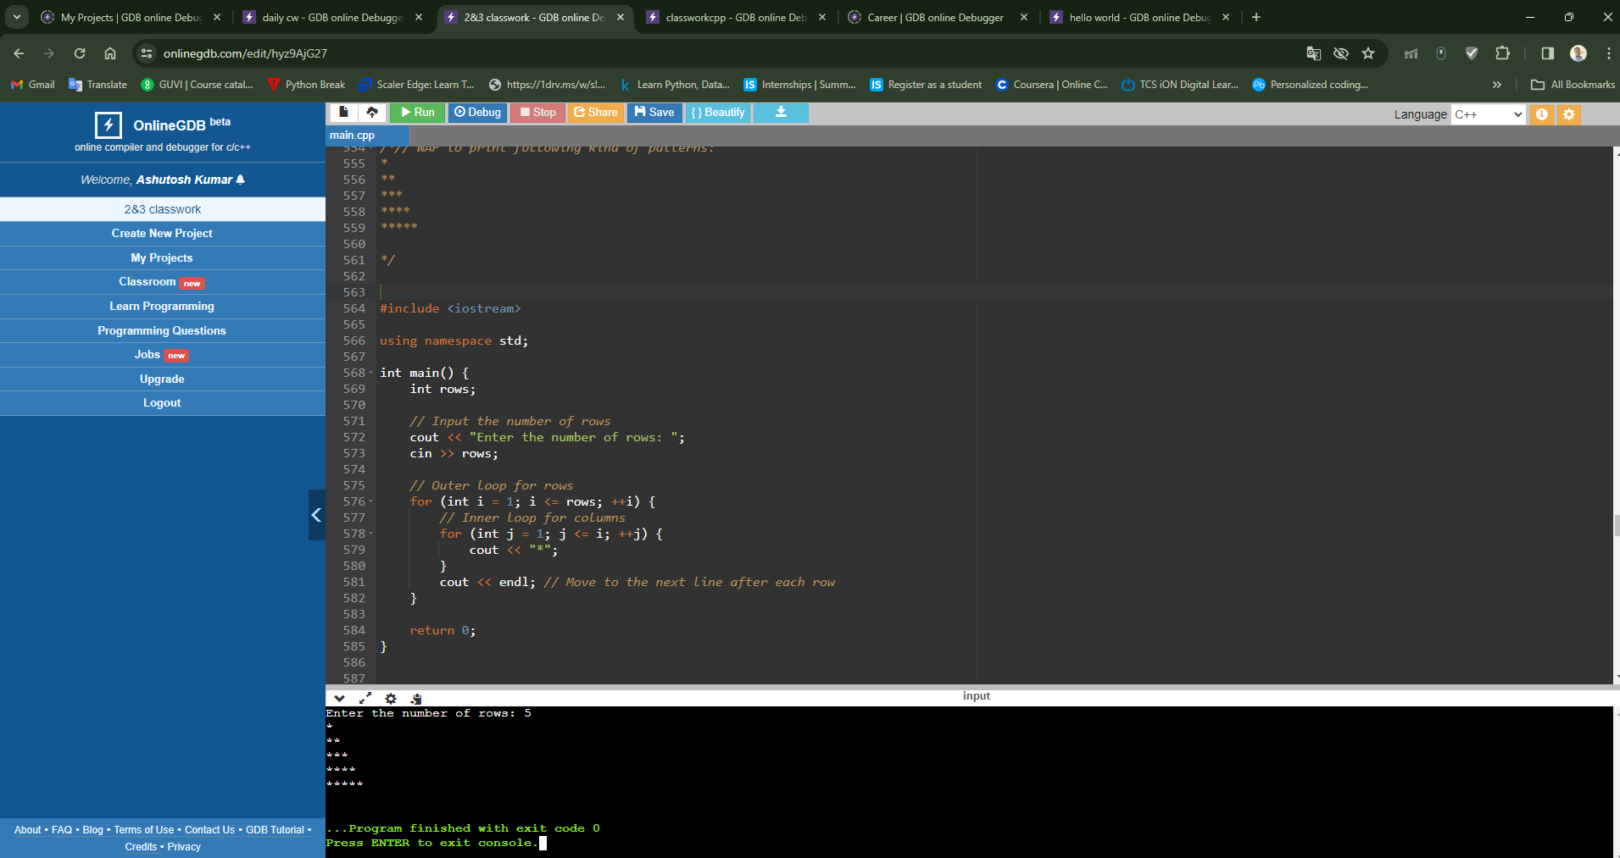

/\*2)

\*

\*\*

\*\*\*

\*\*\*\*

\*\*\*\*\*\*

\*/

#include <iostream>

using namespace std;

int main() {

int rows;

// Input the number of rows

cout << "Enter the number of rows: ";

cin >> rows;

// Outer loop for rows

for (int i = 1; i <= rows; ++i) {

// Inner loop for spaces

for (int j = 1; j <= rows - i; ++j) {

cout << " ";

}

// Inner loop for asterisks

for (int k = 1; k <= i; ++k) {

cout << "\*";

}

cout << endl; // Move to the next line after each row

}

return 0;

}

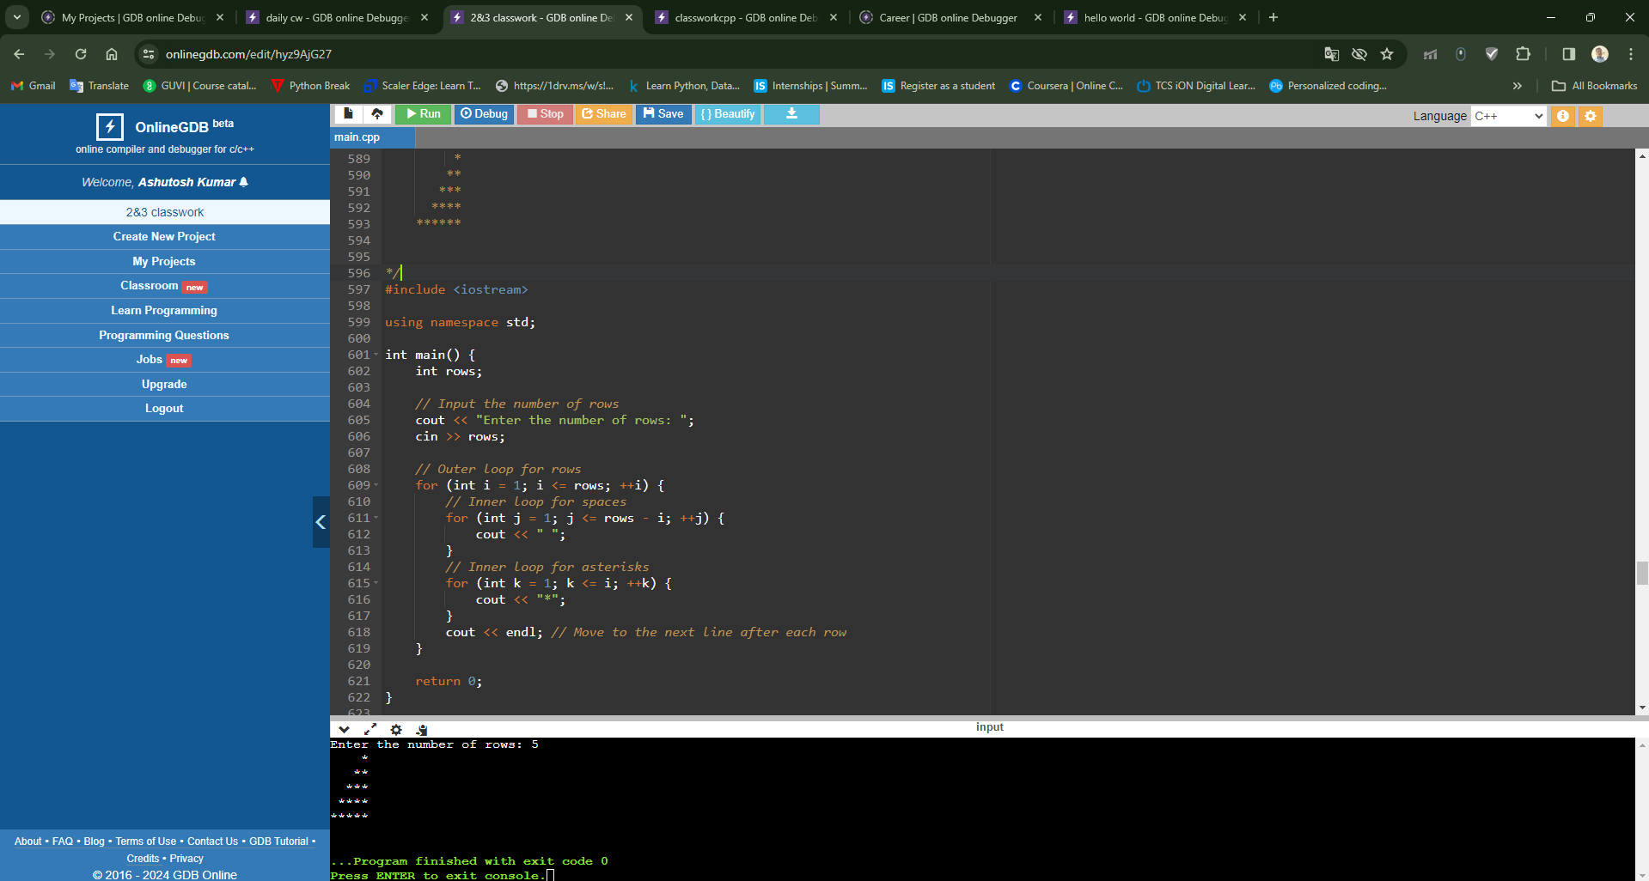

/\* 3)

\*

\*\*\*

\*\*\*\*\*

\*\*\*\*\*\*\*

\*\*\*\*\*\*\*\*\*

\*/

/\*

#include <iostream>

using namespace std;

int main() {

int rows;

// Input the number of rows

cout << "Enter the number of rows: ";

cin >> rows;

// Outer loop for rows

for (int i = 1; i <= rows; ++i) {

// Inner loop for spaces

for (int j = 1; j <= rows - i; ++j) {

cout << " ";

}

// Inner loop for asterisks

for (int k = 1; k <= 2 \* i - 1; ++k) {

cout << "\*";

}

cout << endl; // Move to the next line after each row

}

return 0;

}

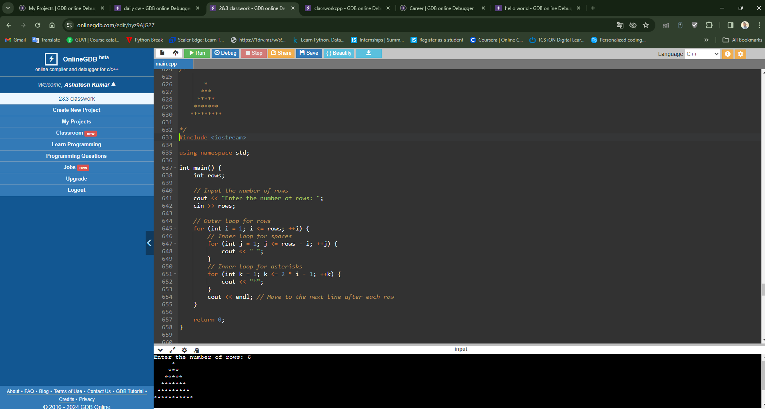

4)

\*/

/\*

// \*\*\*\*\*\*\*\*\*

// \*\*\*\* \*\*\*\*

// \*\*\* \*\*\*

// \*\* \*\*

// \* \*

\*/

/\*

#include <iostream>

using namespace std;

int main() {

int rows;

// Input the number of rows

cout << "Enter the number of rows: ";

cin >> rows;

// Outer loop for rows

for (int i = rows; i >= 1; --i) {

// Inner loop for asterisks

for (int j = 1; j <= i; ++j) {

cout << "\*";

}

// Inner loop for spaces

for (int k = 1; k <= 2 \* (rows - i); ++k) {

cout << " ";

}

// Inner loop for asterisks (right side)

for (int l = 1; l <= i; ++l) {

cout << "\*";

}

cout << endl; // Move to the next line after each row

}

return 0;

}

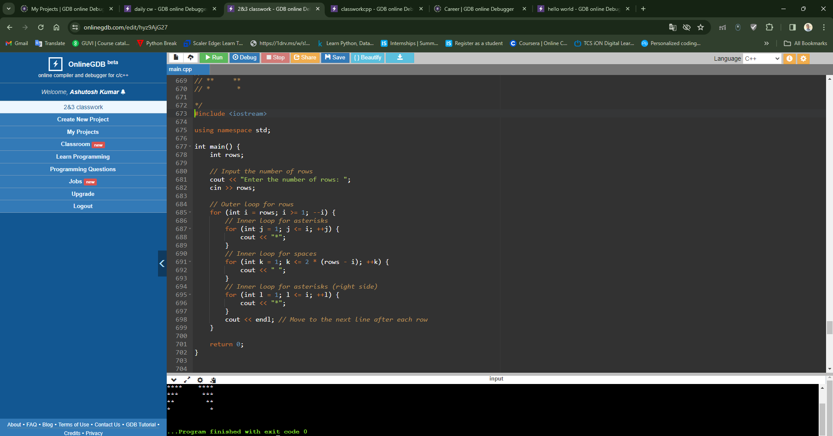

\*/

5)/\*

ABCD

ABC

AB

A

\*/

/\*#include <iostream>

using namespace std;

int main() {

int rows;

// Input the number of rows

cout << "Enter the number of rows: ";

cin >> rows;

// Outer loop for rows

for (int i = rows; i >= 1; --i) {

// Inner loop for characters

for (int j = 1; j <= i; ++j) {

char ch = 'A' + j - 1;

cout << ch;

}

cout << endl; // Move to the next line after each row

}

return 0;

}

\*/

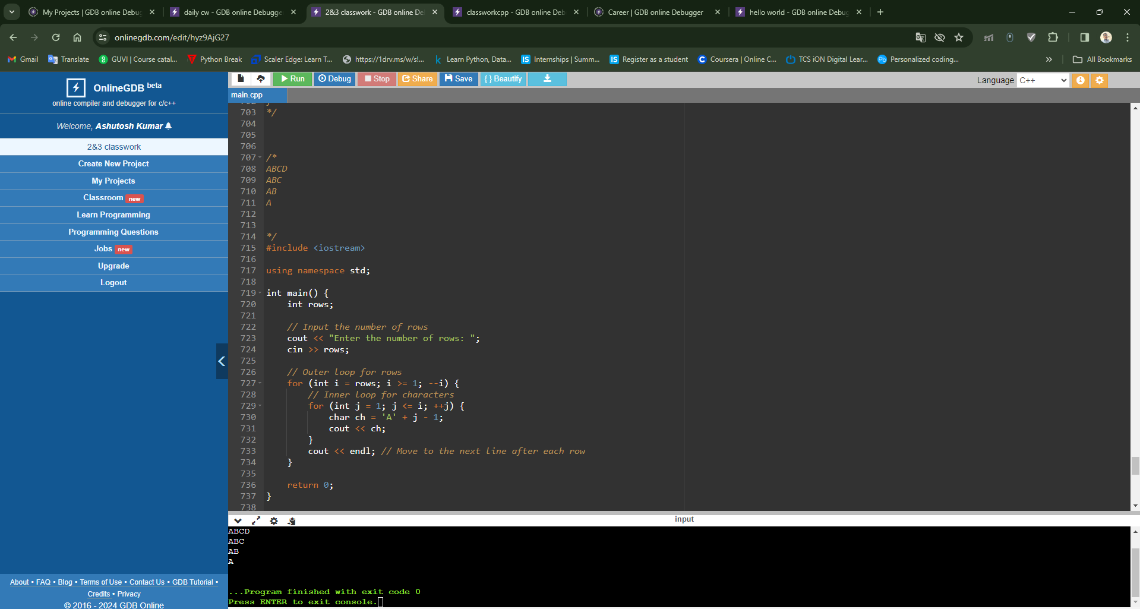

6)/\*

1

12

123

1234

12345

#include <iostream>

using namespace std;

int main() {

int rows;

// Input the number of rows

cout << "Enter the number of rows: ";

cin >> rows;

// Outer loop for rows

for (int i = 1; i <= rows; ++i) {

// Inner loop for numbers

for (int j = 1; j <= i; ++j) {

cout << j;

}

cout << endl; // Move to the next line after each row

}

return 0;

}

